wk1_assign_E_php1.docx

*** Applying What You Have Learned! ***

Topic: *“CHALLENGE ASSIGNMENT”*

Part 1: Display value entered via a form:

* Create the following form named calc_form.htm

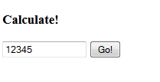

* The form contains one text box and a submit button.
* When submitted, the form data is submitted to a page named results.php
* Use the post or get method for this assignment (your choice).
* Create the results.php page. It should appear as follows:

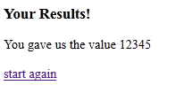

* The results.php page should
  + Retrieve the value entered into the form field from the post or get query
  + Display the value using PHP
  + Include a link that when clicked returns you to the calc_form.htm page

*** For Marks ***

Part 2: Create a new calc_form2.htm and results2.php page.

* Modify the calc_form2.htm page to post the form data to the results2.php page. (no other changes necessary).



* Modify the results2.php page so that ALL OUTPUT IS GENERATED USING   
  PHP CODE. The page should appear as before.



* Note: All html, everything between the opening and closing <body> tags should be coded using PHP, including the link back to the calc_form2.htm page.
* Display your working solution to the instructor for marks.

*CHALLENGE: wk1_assign_E_php1.docx*